Department of Biomedical Engineering The Superior University, Lahore

Computer Programming

Experiment No.1 Introduction to Algorithms

Prepared for: Eisha Nawaz By:
Name: Mazen Abdulkani

ID: Su91-BBETM-F25-006

Section: Biomedical Engineering
Semester: 2nd

Total Marks: 10 Obtained Marks: Signature:

Date:

Experiment No.1 Introduction to Algorithms (Rubrics)

Name: Mazen Abdulkani ID: Su91-BBETM-F25-006

PSYCHOMOTORp

Serial No. | Criteria | Allocated Marks | Unacceptable 0% | Poor 25% | Fair 50% | Good 75% | Excellent 100% | Total Obtained
1 | Follow Procedures | 2 | 0 | 0.5 | 1 | 1.5 | 2
2 | Designing an Algorithm | 4 | 0 | 0.5 | 1 | 2.5 | 4
Sub-Total |  | 6 | Sub Total Marks Obtained in Psychomotor (P)

AFFECTIVE

Serial No. | Criteria | Allocated Marks | Unacceptable 0% | Poor 25% | Fair 50% | Good 75% | Excellent 100% | Total Obtained
1 | Respond to Question s | 2 | 0 | 0.5 | 1 | 1.5 | 2
2 | Lab Report | 2 | 0 | 0.5 | 1 | 1.5 | 2
Sub-Total |  | 4 | Sub Total Marks Obtained in Affective (A)

Instructor Name: | Miss Eisha Nawaz | Total Marks (P+A): | 10
Instructor Signature: |  | Obtained Marks (P+A):

CONTENTS OF LAB 1
- Objective: 4
- Introduction to Algorithm 4
2.1 | Example 1 | 4
2.2 | Example 2 | 5
2.3 | Example 3 | 5
2.4 | Example 4 | 5
2.5 | Example 4 | 6
2.6 | Example 6 | 6
2.7 | example 7 | 7
2.8 | example 8 | 7
Lab Tasks 9
3.1 | Task 1 | 9
3.2 | Task 2 | 9
3.3 | Task 3 | 9
3.4 | Task 4 | 9
3.5 | Task 5 | 9
Home Assignment 10
4.1 | Task 1 | 10
4.2 | Task 2 | 10

3

4

Introduction to Algorithm

OBJECTIVE:
To briefly introduce of algorithm for defining and describing a big problem in small parts, so that it is very easy to execute. Its finite sequence of step to solve a problem.

INTRODUCTION OF ALGORITHM
An algorithm is a process or set of rules which must be followed to complete task. This is basically the step-by-step procedure to complete any task.
- An algorithm should be basic and easy to perform.
- Each step started with a specific indentation like, “Step-1”,
- There must be “Start” as the first step and “End” as the last step of the algorithm.
There are some basics steps to make an algorithm:
- Start – Start the algorithm
- Input – Take the input for values in which the algorithm will execute.
- Conditions – Perform some conditions on the inputs to get the desired output.
- Output – Printing the outputs.
- End – End the execution.

Let’s take some examples of algorithms for computer science problems.

  - USE OF THE ALGORITHMS:

Algorithms play a crucial role in various fields and have many applications. Some of the key areas where algorithms are used include:

Computer Science: Algorithms form the basis of computer programming and are used to solve problems ranging from simple sorting and searching to complex tasks such as artificial intelligence and machine
learning.
Mathematics: Algorithms are used to solve mathematical problems, such as finding the optimal solution to a system of linear equations or finding the shortest path in a graph.
Operations Research: Algorithms are used to optimize and make decisions in fields such as transportation, logistics, and resource allocation.
Artificial Intelligence: Algorithms are the foundation of artificial intelligence and machine learning, and are used to develop intelligent systems that can perform tasks such as image recognition, natural language processing, and decision-making.
Data Science: Algorithms are used to analyze, process, and extract insights from large amounts of data in fields such as marketing, finance, and healthcare.

  - EXAMPLE 1
The given example shows the algorithm of finding the area of a rectangle:
Table 1 Example 1

Step 1: | Start
Step 2: | Take the Height and Width of the rectangle as input.
Step 3: | Declare a variable as “area”
Step 4: | Multiply Height and Width
Step 5: | Store the multiplication to “Area”, (its look like area = Height x Width)
Step 6: | Print “area”;
Step 7: | End

  - EXAMPLE 2
The given example shows the algorithm of finding the area of a circle:
Table 2 Example 2

Step 1: | Start
Step 2: | Declare variable R, P, AREA
Step 3: | Read value R
Step 4: | Set P=3.14
Step 5: | AREA=P*R*R
Step 6: | Print Area

Step 6: | End

  - EXAMPLE 3
The given example shows the algorithm of finding the greatest between 3 numbers:
Table 3 Example 3

Step 1: | Start
Step 2: | Take 3 numbers as input, say A, B, and C.
Step 3: | Check if(A>B and A>C)
Step 4: | Then A is greater
Step 5: | Print A
Step 6: | Else
Step 7: | Check if(B>A and B>C)
Step 8: | Then B is greater
Step 9: | Print B
Step 10: | Else C is greater
Step 11: | Print C
Step 12: | End

  - EXAMPLE 4
The given example shows the algorithm of adding two numbers entered by the user:
Table 4 Example 4

Step 1: | Start
Step 2: | Declare variables num1, num2 and sum.
Step 3: | Read values num1 and num2
Step 4: | Add num1 and num2 and assign the result to sum. Sum = num1+num2
Step 5: | Print sum
Step 6: | End

  - EXAMPLE 4
The given example shows the algorithm of finding whether a given number is odd or even:

    - Odd numbers are the numbers that are not divisible by 2, it starts from 1. In other words, these numbers leave 1 as a remainder.

    - Even numbers are the numbers that are divisible by 2, it starts from 0. In other words, these numbers leave 0 as a remainder.
Table 5 Example 5

Step 1: | Start
Step 2: | Declare variable n, remainder.
Step 3: | Read number n
Step 4: | Find the remainder of the number divided by 2 using  Remainder = n % 2
Step 5: | Check:  If remainder ==0, then display “Even”.
Step 6: | Else
Step 7: | Display “ODD”
Step 8: | End

  - EXAMPLE 6
The given example shows the algorithm of swapping the value of 2 integers:
First way is to store one of the variable value, say A’s value in another memory location, a temporary third variable T. Then copy B’s value into A and then T’s value into A. In this approach we need an additional storage to store the value of a number.
Table 6 Example 6

Step 1: | Start
Step 2: | Declare variable A, B, N.
Step 3: | Input A, B.
Step 4: | N = A;  A = B;  B = N;
Step 5: | Print A
Step 6: | Print B
Step 7: | End

  - EXAMPLE 7
The given example shows the algorithm to find out the profit or loss of product:
Table 7 Example 7

Step 1: | Start
Step 2: | Input product price as pp

Step 3: | Input selling price as sp
Step 4: | If pp < sp  Print profit  as pp - sp
Step 5: | Else If sp < pp  Print loss  As sp-pp
Step 6: | If pp = sp  Print no profit no loss
Step 7: | End

  - EXAMPLE 8
The given example shows the algorithm to find the grade of student according to his/her marks:
Table 8 Example 8

Step 1: | Start
Step 2: | Declare variable n, obtained marks, total marks
Step 3: | Input obtained marks, total marks
Step 4: | n = (obtained marks / total marks) *100
Step 5: | If n > 80  Print grade A+
Step 6: | If n > 70 and n<80  Print grade A
Step 7: | Else If n > 60 and n<70  Print grade B
Step 8: | Else If n > 50 and n<60  Print grade C
Step 9: | Else If n > 40 and n<50  Print grade D
Step 10: | Else If n > 33 and n<40  Print grade E
Step 11: | Else  Print grade F
Step 12: | End

LAB TASKS
Solve the following tasks.

  - TASK 1
Write an algorithm where the science, math and English marks of a student are input. Calculate the average percentage. If the percentage is above 40 then display passed else display failed.

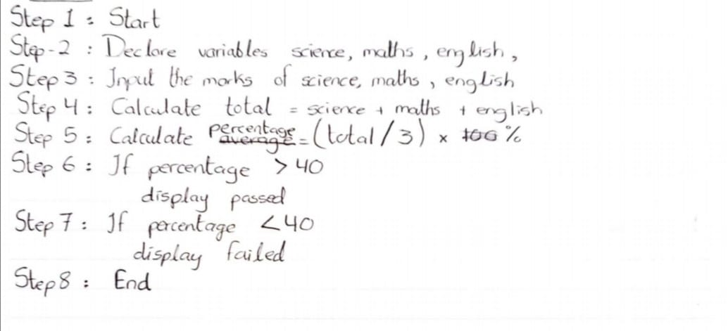

  - TASK 2

Write an algorithm of finding the Area of the Right-angle Triangle.

Hint:
Area = ½(base*height)
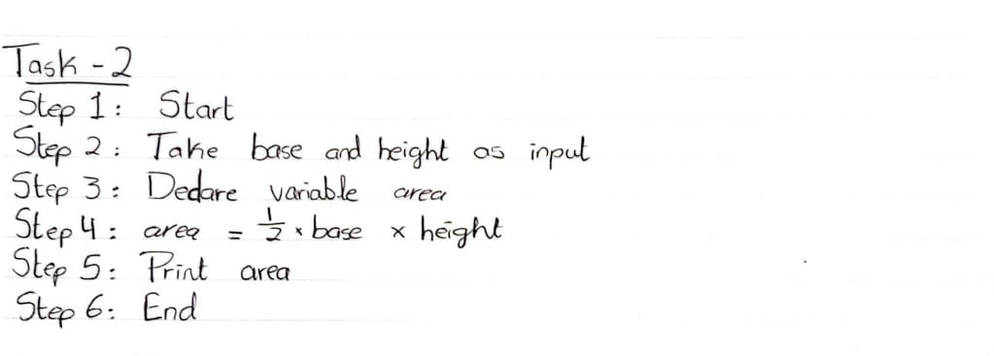

  - TASK 3
Write an algorithm where the temperature in centigrade is entered. If the input temperature is more than 30 degrees, display “it is warm today”, else display “It is cool today”.

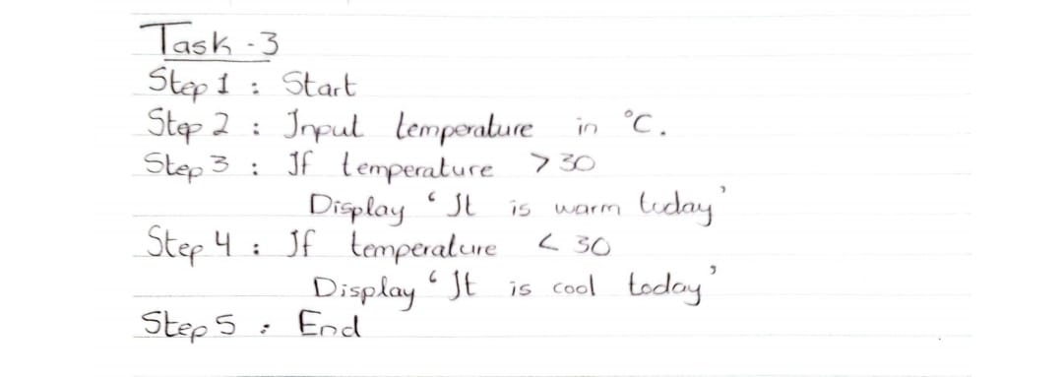

  - TASK 4
Write an algorithm where the user entered the total number of umbrellas, he/she wants to buy. Price of one umbrella id Rs 400. Calculate the total price of umbrella user purchase and display the result.
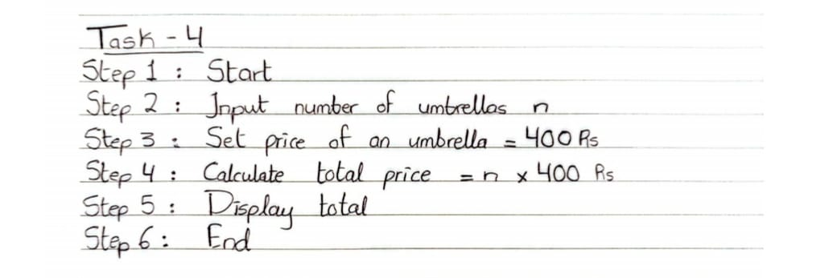
  - TASK 5
Write an algorithm of finding the sum and the average of three numbers and display the sum and average separately.

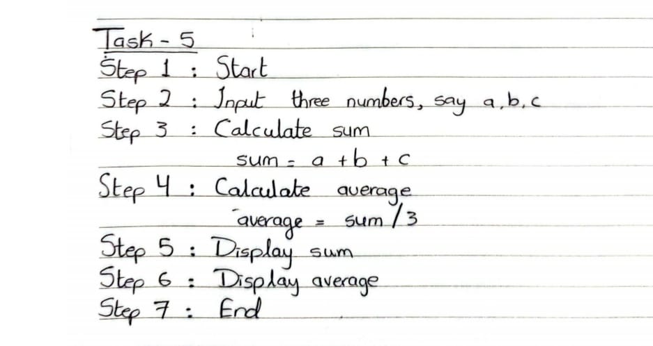

HOME ASSIGNMENT

  - TASK 1
Write an algorithm to find the circumference of a circle with a given radius.

Hint:
C=2πr
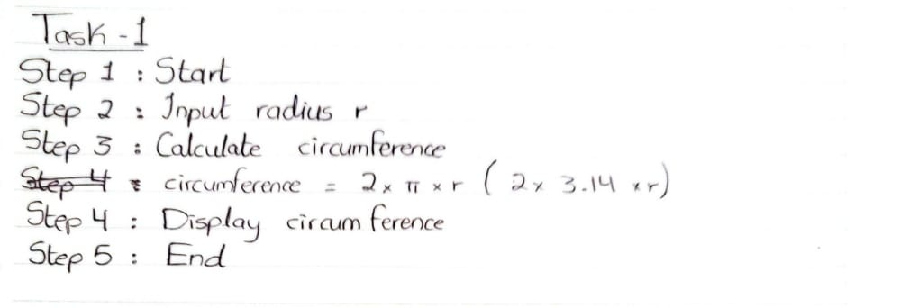

  - TASK 2
Write an algorithm to check the temperature, if the temperature in Fahrenheit covert it in Celsius, and if the temperature in Celsius covert it in Fahrenheit. Display the final temperature.
